Getting the ½ status failed error and resolve that

We have previously launch the instance named as ‘demo’. We will make its status ½ status failed

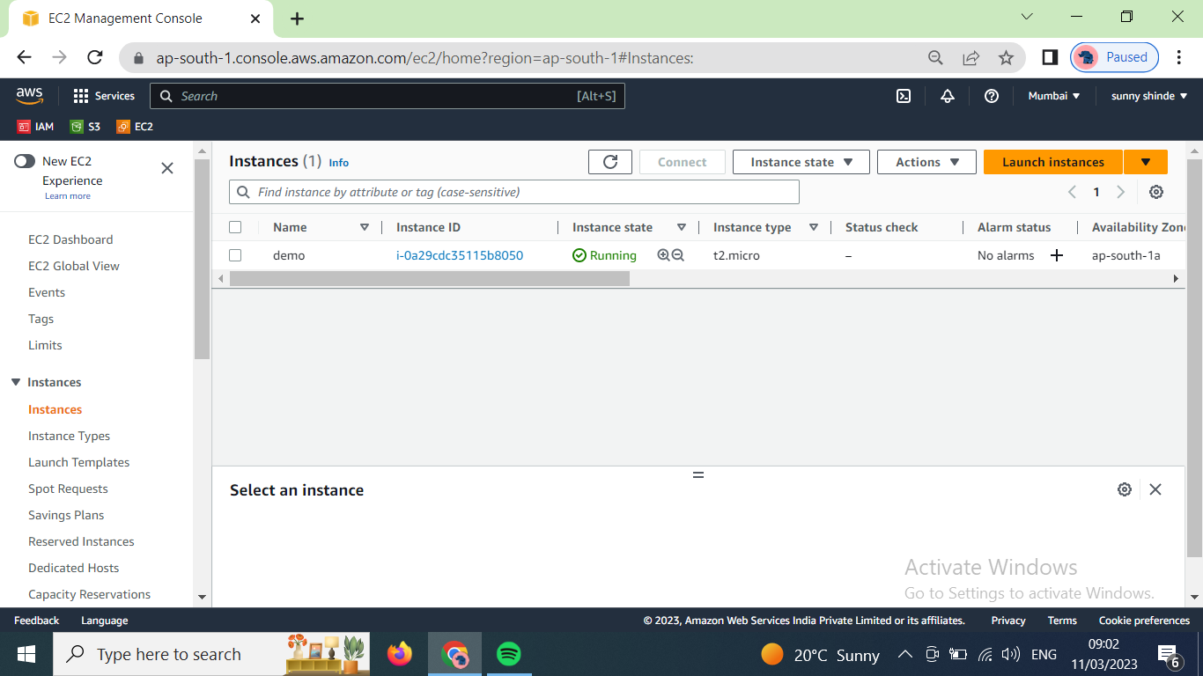

The ½ error shows when there are software issues and when instance is unrecheable. For example if we remove boot file then restart the instance then it will not start due to absence of boot files, and instance becomes unrecheable and shows ½ status failed error.

Now, connect the instance.

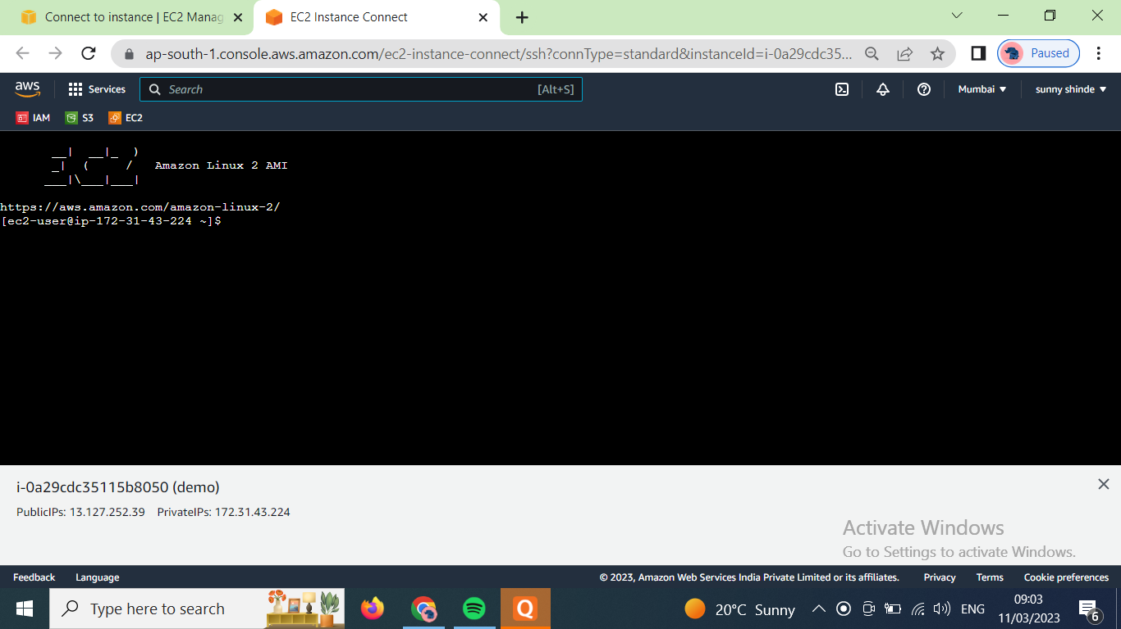

Now use ‘sudo -i’ to switch into root user. Then go to the /boot directory using ‘cd /boot’. Then remove the grub2 file using ‘rm –rvf grub2’

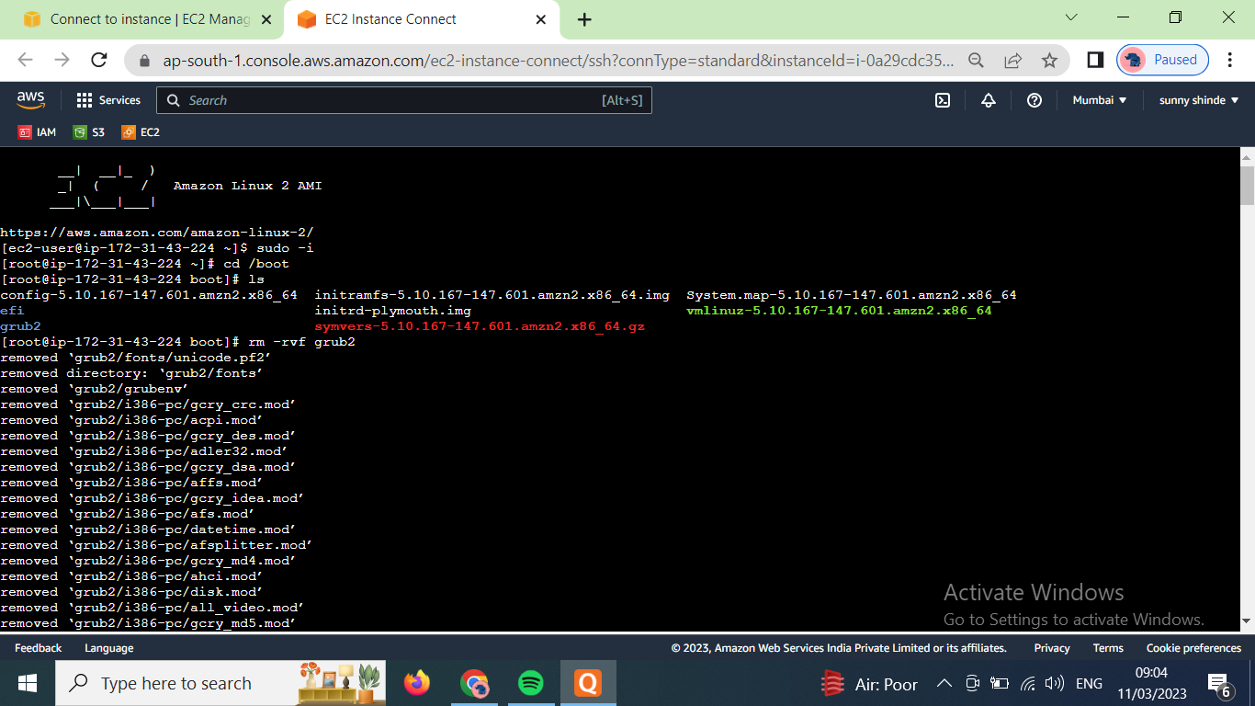

Now close the instance tab window and go to the previous page whome where we connect the instance. Select the instance, click on actions –> stop instance

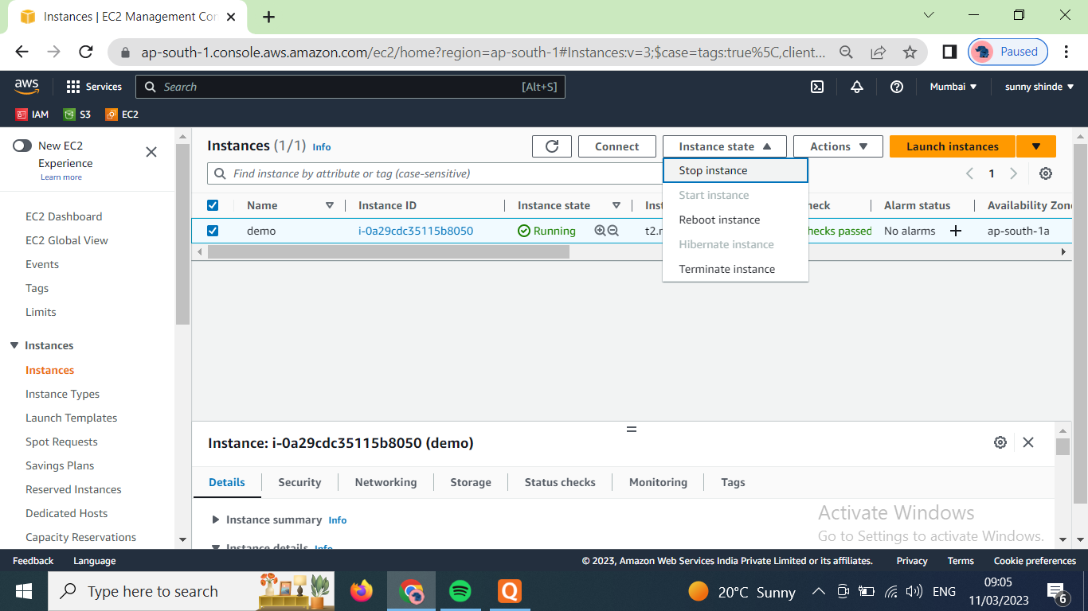

After stopping the instance strat it again

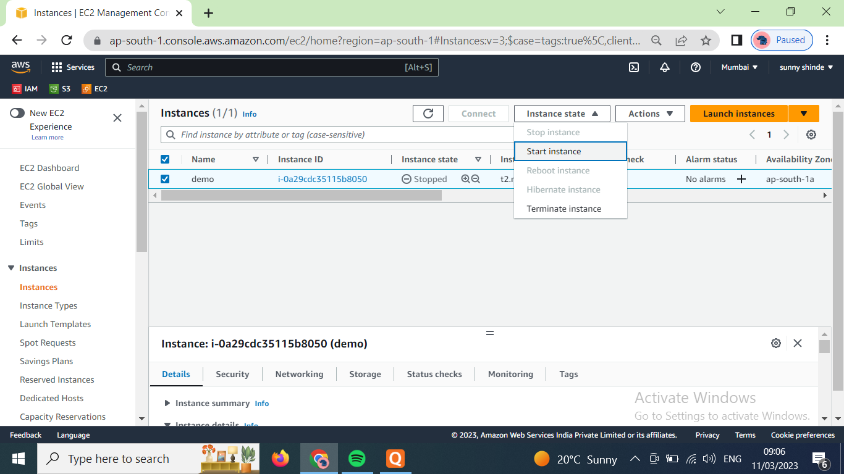

After few minutes it shows the error of ½ status failed.

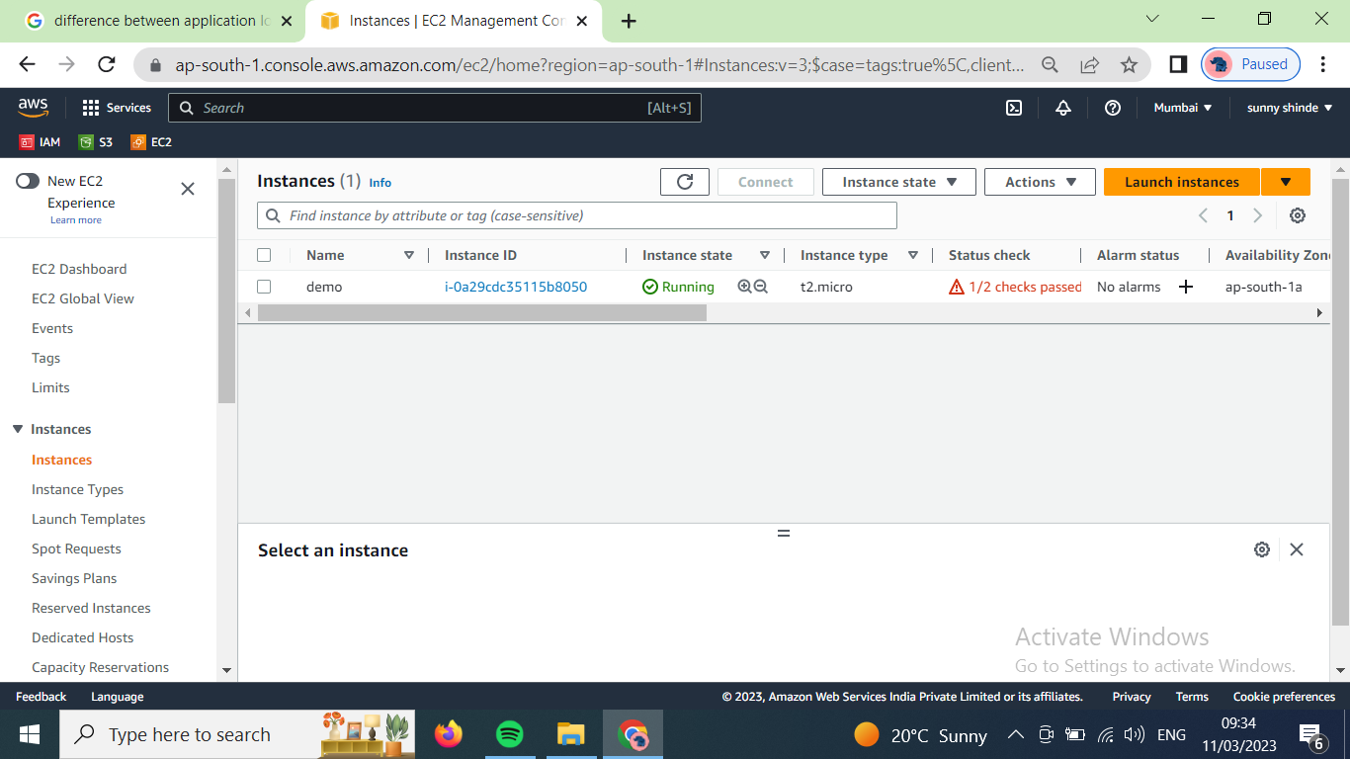

Now to resolve the the issue we will replace its volume with new version of it

Select the instance click on actons 🡪monitor and troubleshoot—> replace root volume

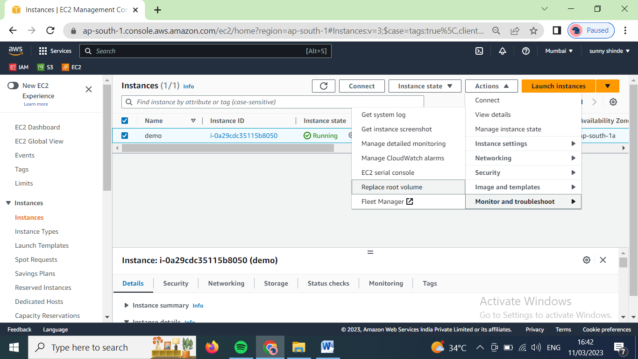

Just click on create replacement task

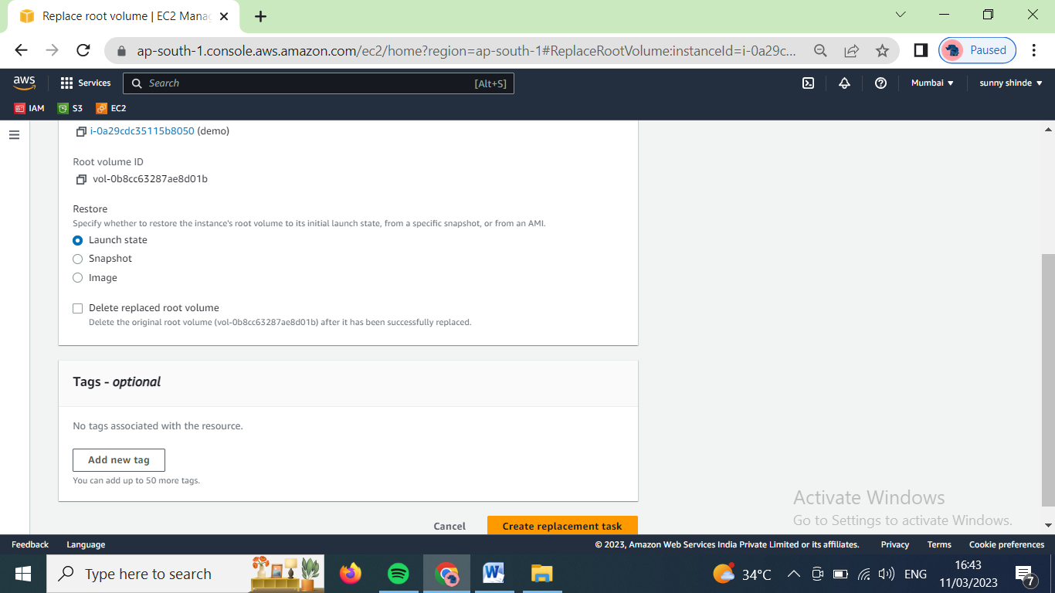

Now after few minutes root volume will replaced with its new version.

And issue will resolve